美国土木工程师学会（ASCE）

The American Society of Civil Engineers

美国土木工程师学会（The American Society of Civil Engineers，简称ASCE）成立于1852年,至今已有150多年的悠久历史，是历史最久的国家专业工程师学会。现在，ASCE已是全球土木工程领域的领导者；所服务的会员来自159个国家超过13万的专业人员。为了鼓励在工程师之间分享更多的信息，ASCE已和其他国家的65个土木工程学会达成了合作协议。

ASCE也是全球最大的土木工程信息知识的出版机构，每年有5万多页的出版物。2007年学会出版物包括30种技术和专业期刊、会议录，以及各种图书、委员会报告、实践手册、标准和专论等。ASCE出版的期刊大部分被SCI、EI收录，是土木工程学科的重要核心期刊。
ASCE Online Research Library是全球最大的土木工程全文文献资料库。
它收录了ASCE所有专业期刊（回溯至1990年）和会议录（回溯至2001年，及1996-2000年间的部分会议录），总计超过40,000篇全文、400,000页资料；每年新增约4,000篇文献。

研究者可以在此一站式检索土木工程领域的核心资源。

请访问：
www.ascelibrary.org
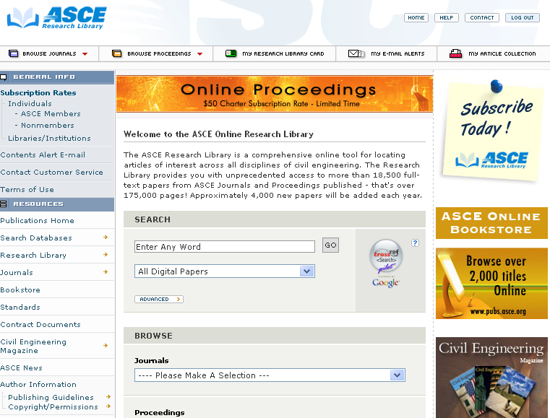

The American Society of Civil Engineers 期刊（30种）

- Journal of Aerospace Engineering
- Journal of Architectural Engineering
- Journal of Bridge Engineering
- Journal of Cold Regions Engineering
- Journal of Composites for construction
- Journal of Computing in Civil Engineering
- Journal of Infrastructure Systems
- Journal of Energy Engineering
- Journal of Engineering Mechanics
- Journal of Environmental Engineering
- Journal of Structural Engineering
- Journal of Hydraulic Engineering
- Journal of Hydrologic Engineering
- Journal of Surveying Engineering
- J of Construction in Engineering and Management
- Journal of Irrigation and Drainage Engineering
- Journal of Transportation Engineering
- Journal of Management in Engineering
- Journal of Materials in Civil Engineering
- Leadership and Management in Engineering
- Natural Hazards Review
- Journal of Performance of Constructed Facilities
- Journal of Professional Issues in Engineering Education and Practise
- Practice Periodical of Hazardous, Toxic & Radioactive Waste Management
- Practice Periodical on Structural Design and Construction
- Journal of Urban Planning and Development
- J of Water Resources Planning and Management
- J of Waterway, Port, Coastal & Ocean Engineering
- J of Geotechnical and Geoenvironmental Engineering
- International Journal of Geomechanics

